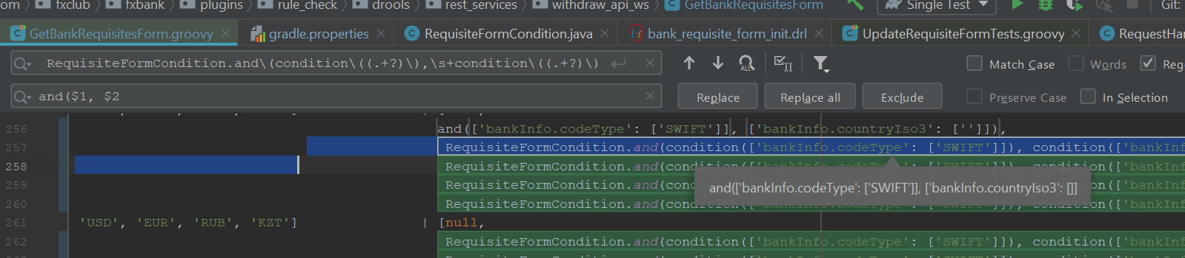

RequisiteFormCondition.and\(condition\((.+?)\),\s+condition\((.+?)\)

Plain string

Escaping characters as a plain

Capturing groups

NON GREEDY

Any amount of escape characters

$N (1, 2 … , N) - reference